**Jyotsna Bansode**

**Task 4**

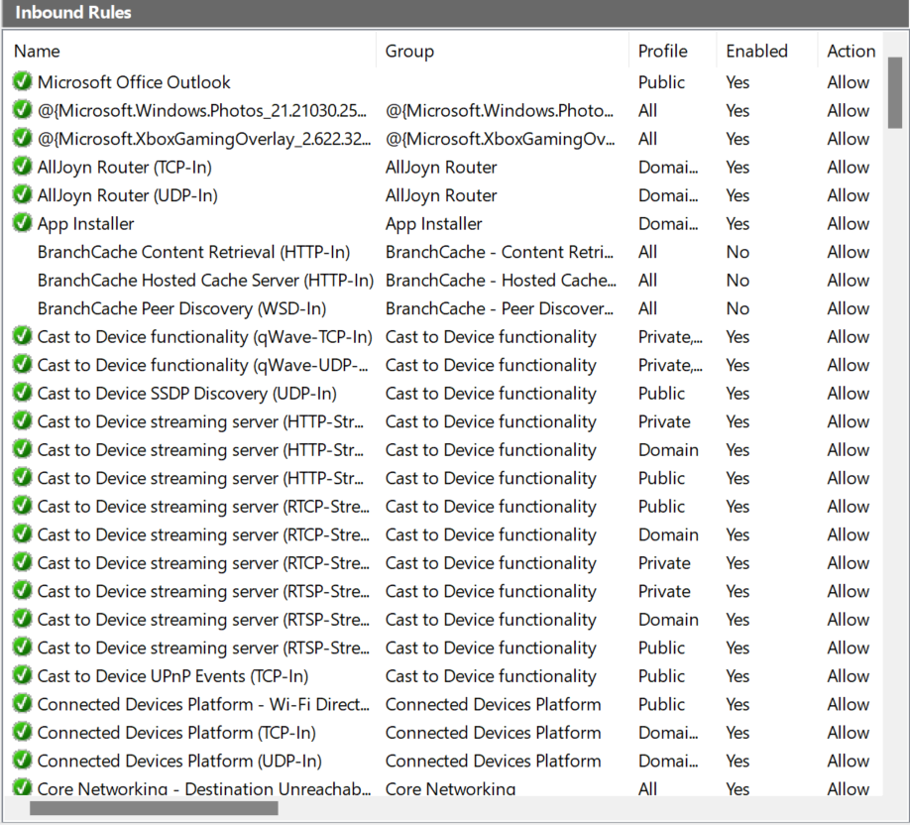

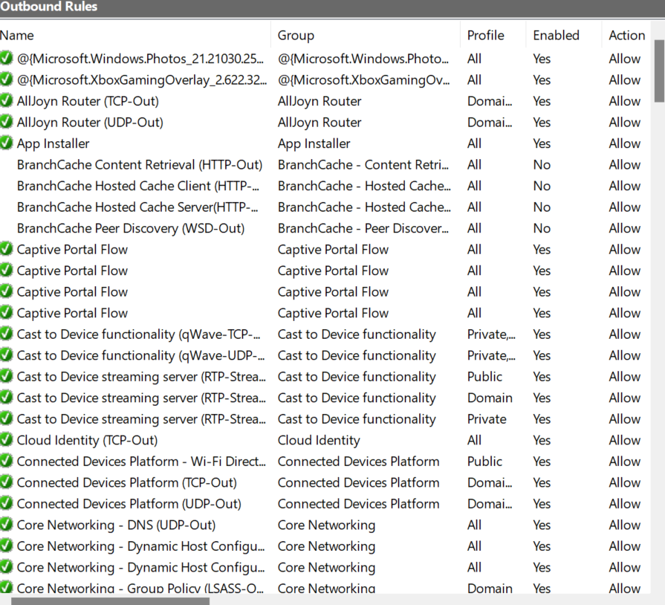

**Added a rule to block inbound traffic on port 23**

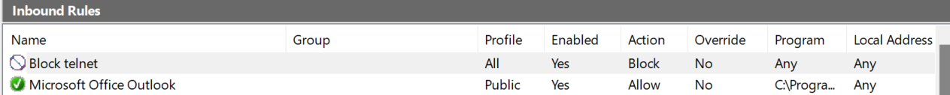

**Tested the rule, result as below**

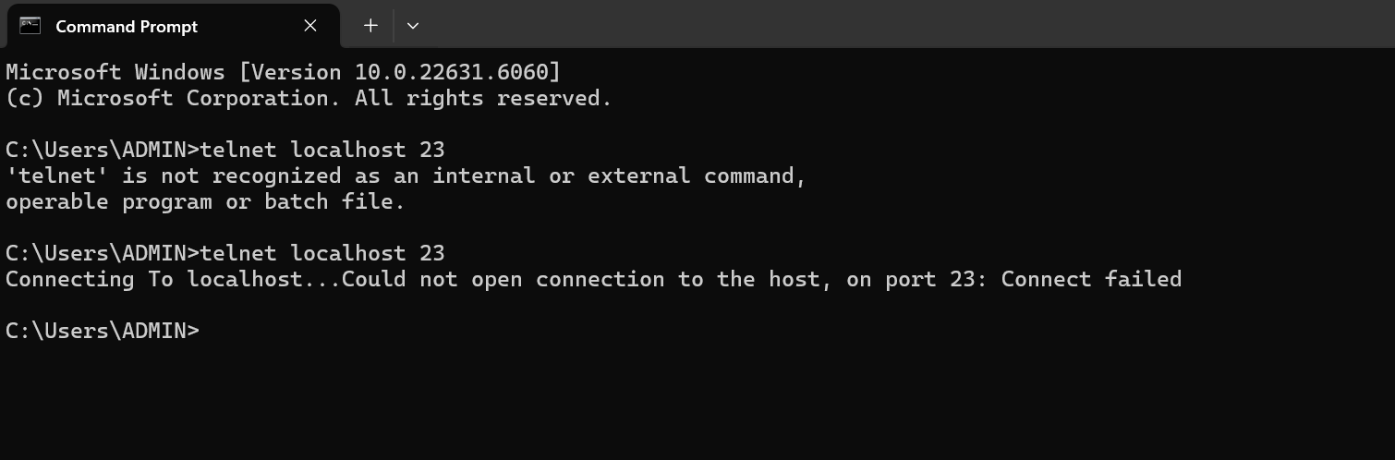

**After testing deleted the rule**

